SOLUTION OF MODULE 5
Question 1: https://leetcode.com/problems/power-of-two/submissions/2192942489/
bool isPowerOfTwo(int n) {
if (n <= 0) {
return false;
}
// A power of two in binary has only one set bit (e.g., 4 is 0100, 3 is 0011)
return (n & (n - 1)) == 0;
}
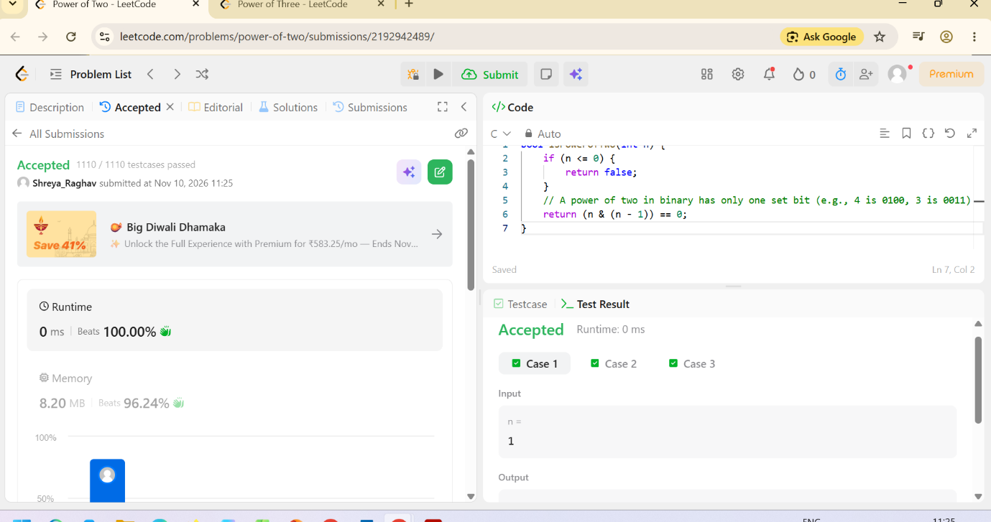

Question 2: https://leetcode.com/problems/power-of-three/submissions/2192942880/
bool isPowerOfThree(int n) {
if (n <= 0) {
return false;
}
while (n % 3 == 0) {
n /= 3;
}
return n == 1;
}

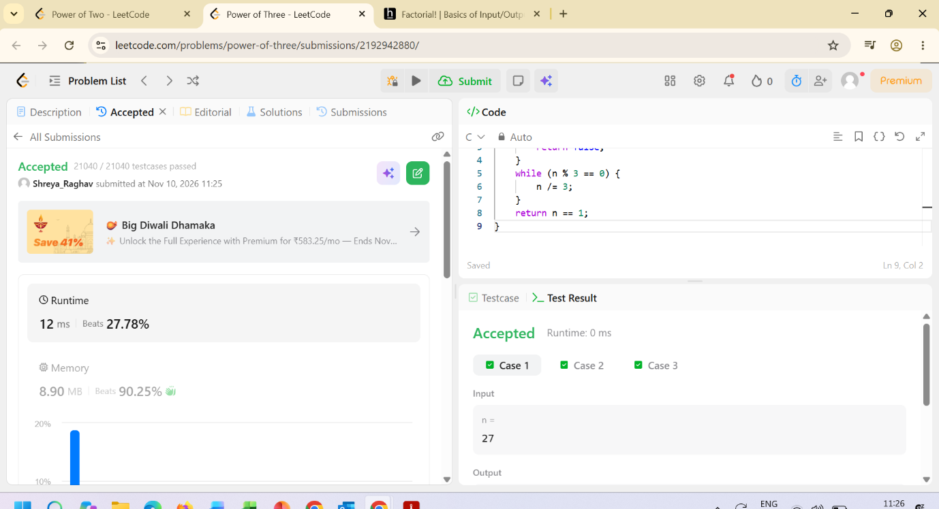
Question 3: https://www.hackerearth.com/practice/basic-programming/input-output/basics-of-input-output/practice-problems/algorithm/find-factorial/
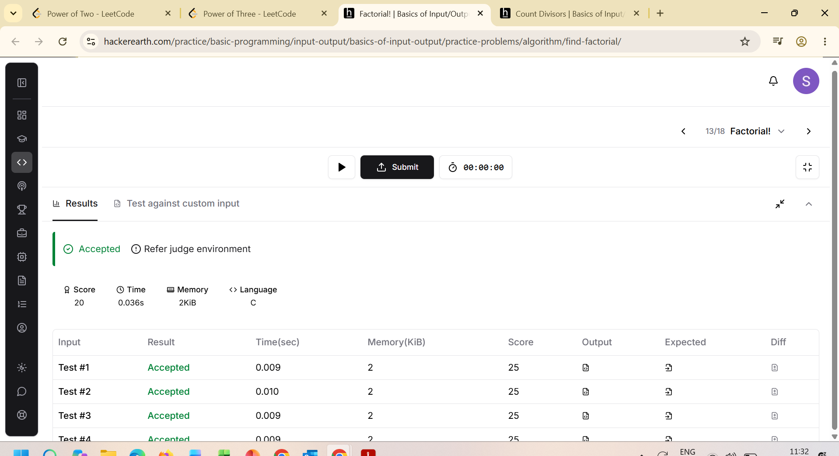
#include <stdio.h>

int main() {
int n;
scanf("%d", &n);

long long factorial = 1;

for (int i = 1; i <= n; i++) {
factorial *= i;
}

printf("%lld\n", factorial);

return 0;
}
Question 4: https://www.hackerearth.com/practice/basic-programming/input-output/basics-of-input-output/practice-problems/algorithm/count-divisors/
#include <stdio.h>

int main() {
int l, r, k;

// Read 3 space-separated integers l, r, and k
scanf("%d %d %d", &l, &r, &k);

int count = 0;

// Loop from l to r (inclusive)
for (int i = l; i <= r; i++) {
if (i % k == 0) {
count++;
}
}

// Print the final count
printf("%d\n", count);

return 0;
}

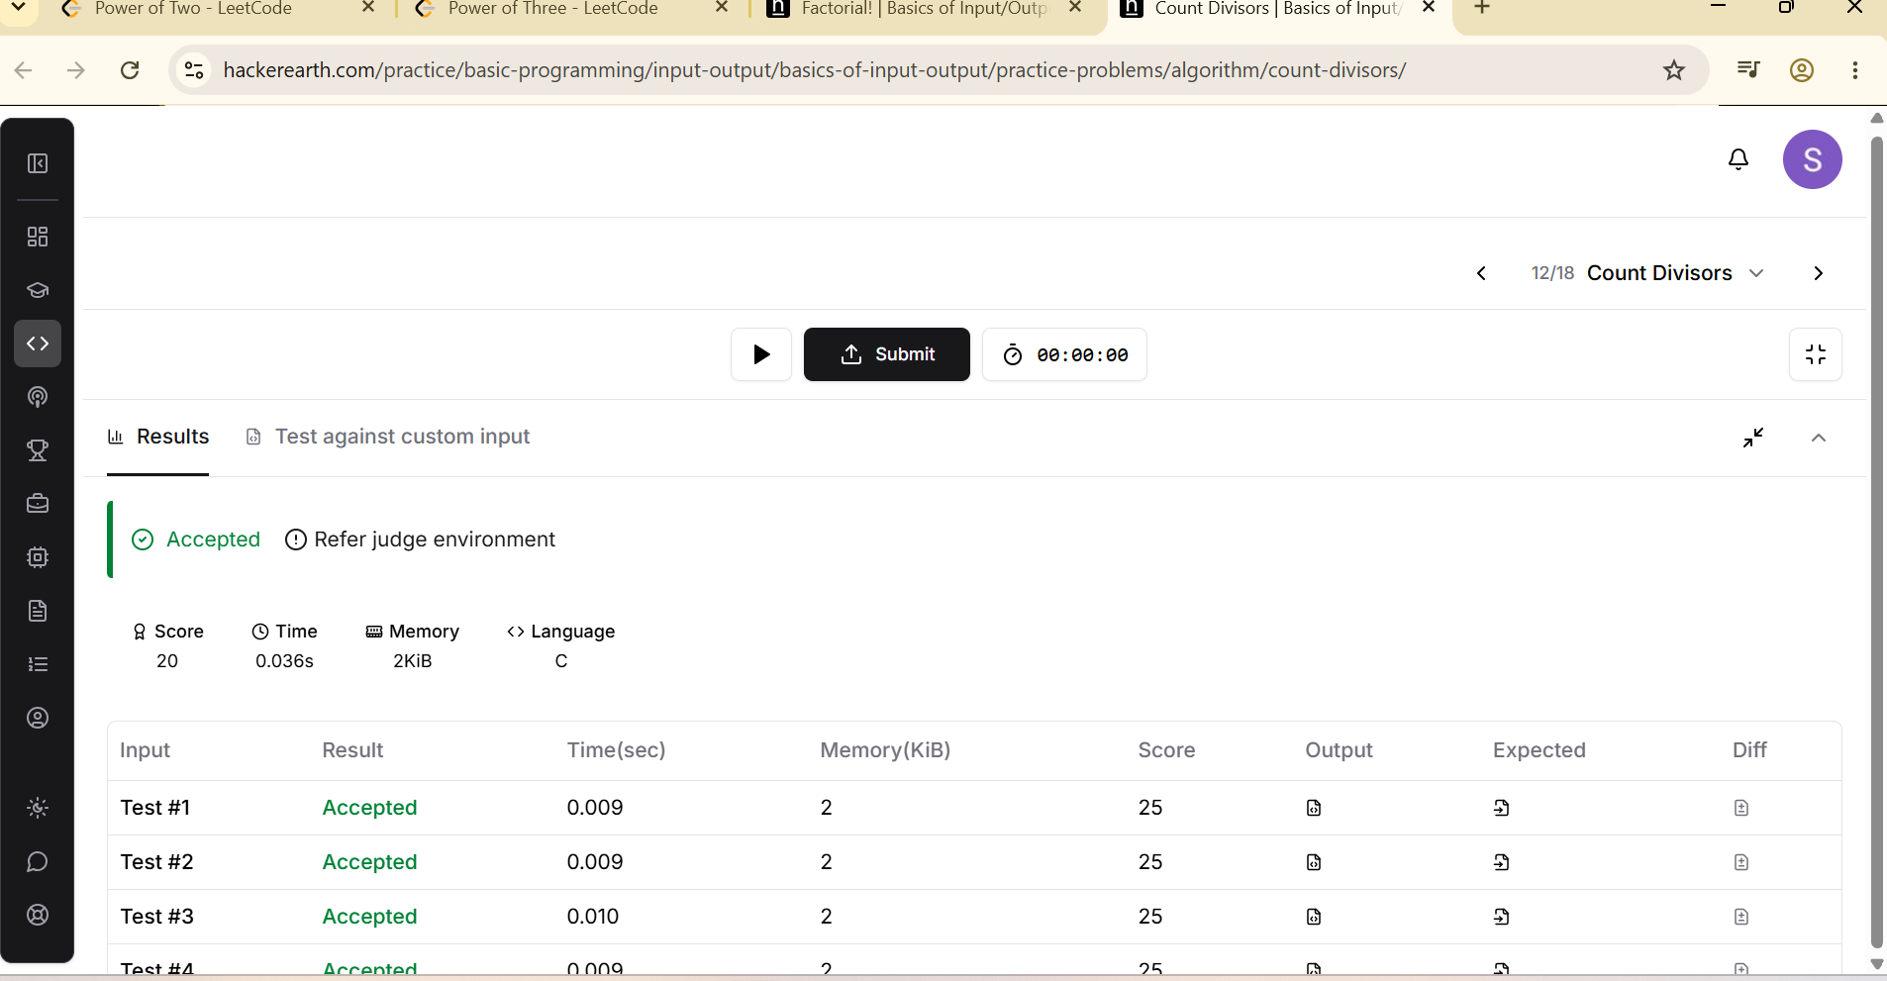

Question 5: https://www.hackerearth.com/problem/algorithm/prime-numbers/
#include <stdio.h>

int main() {
int n;
scanf("%d", &n);

int is_prime = 1;

if (n <= 1) {
is_prime = 0;
} else {
for (int i = 2; i * i <= n; i++) {
if (n % i == 0) {
is_prime = 0;
break;
}
}
}

if (is_prime) {
printf("1\n");
} else {
printf("0\n");
}

return 0;
}
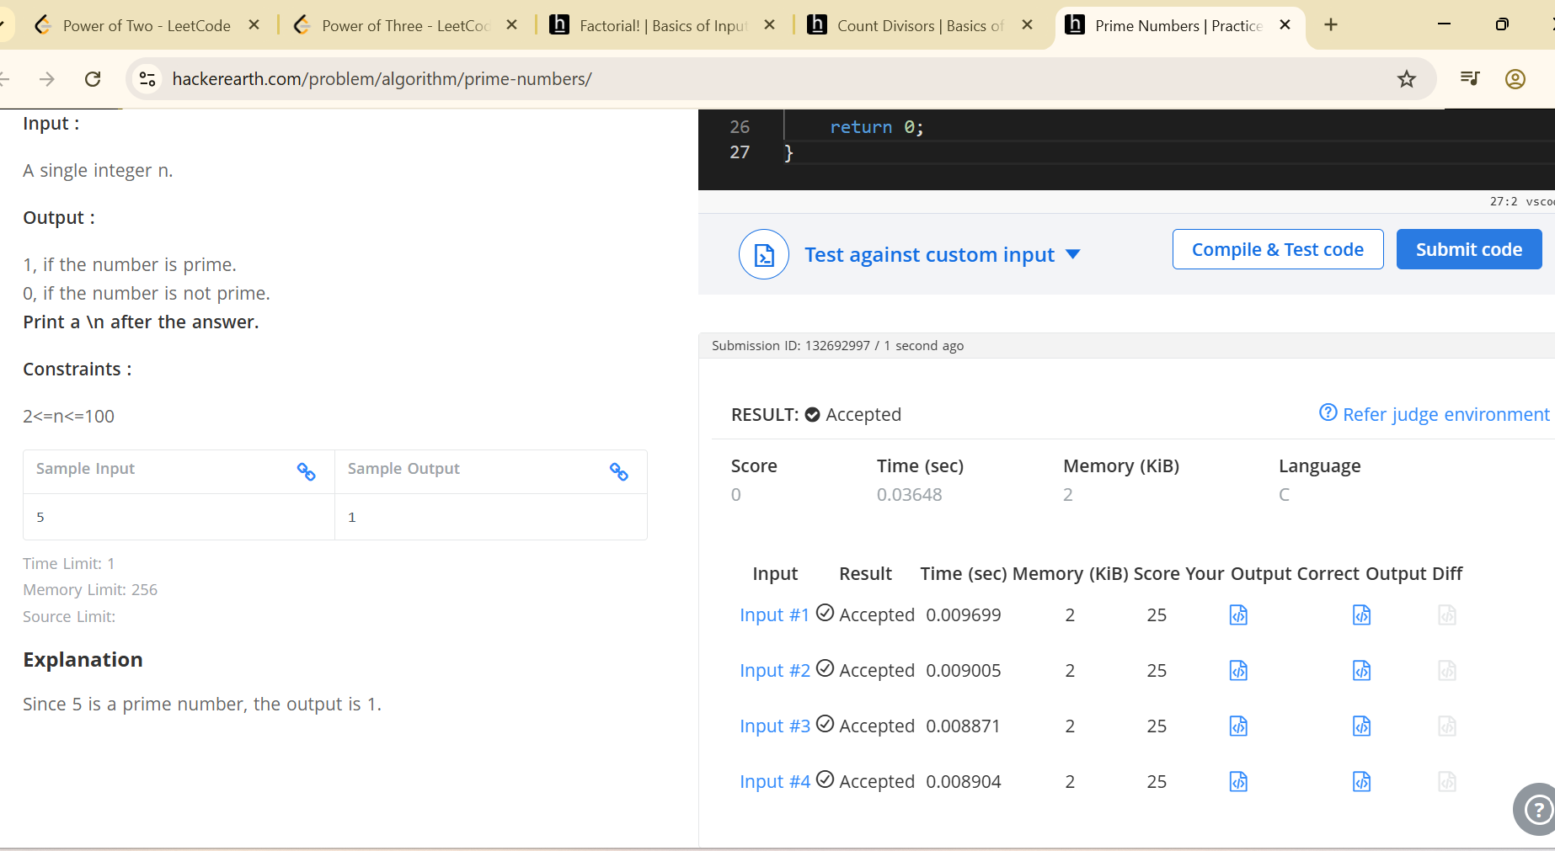

Question 6: https://leetcode.com/problems/perfect-number/description/
bool checkPerfectNumber(int num) {
if (num <= 1) {
return false;
}

int sum = 1; // 1 is always a proper divisor for num > 1

for (int i = 2; i * i <= num; i++) {
if (num % i == 0) {
sum += i;
if (i * i != num) {
sum += (num / i);
}
}
}

return sum == num;
}



